**Figures**

**Fig 1:**



**Fig 2:**

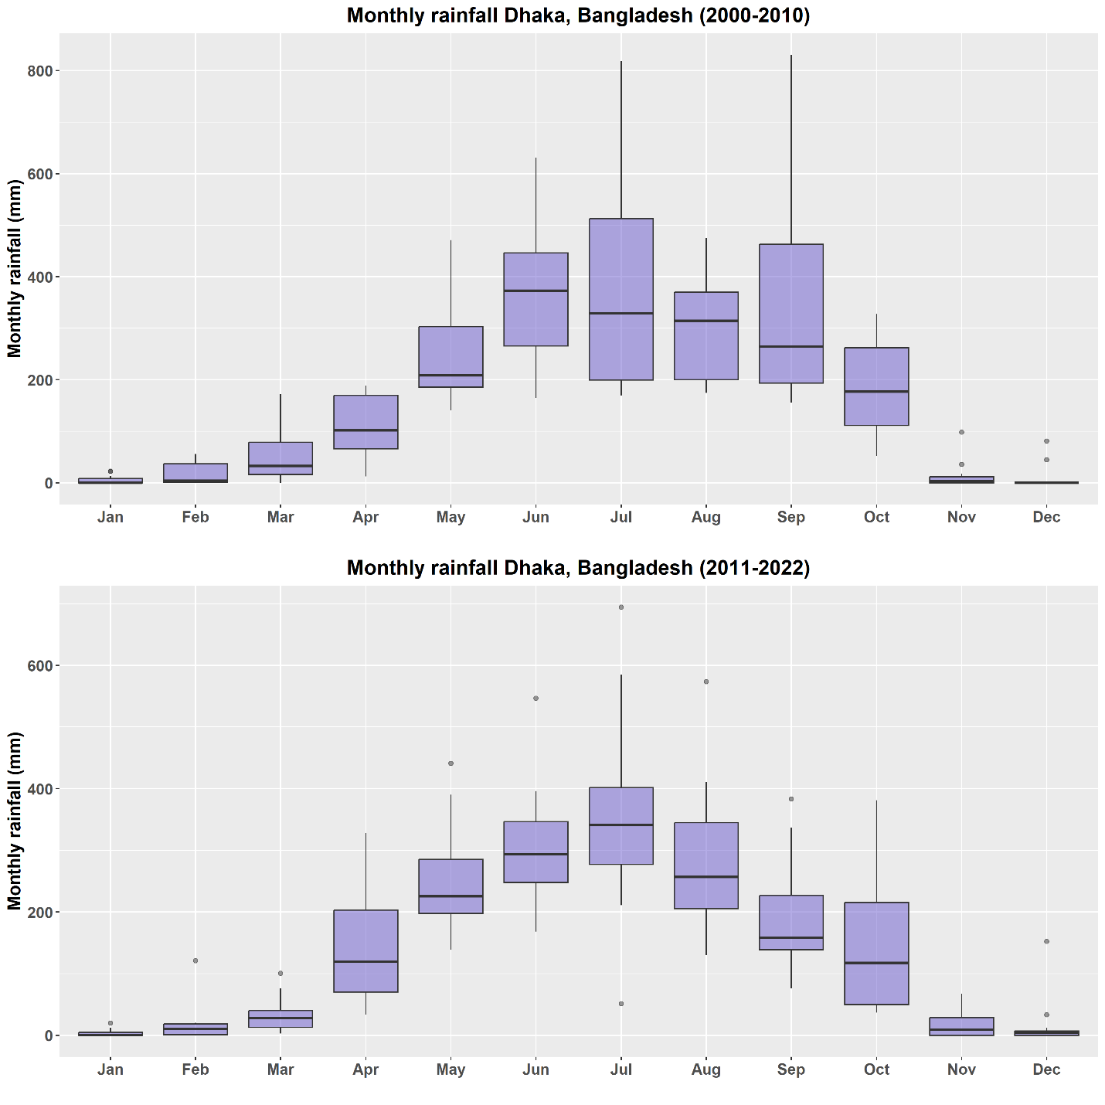

**Fig 3:**



**Fig 4:**

